**GENERAL PHYSICS 1 VECTOR ADDITION and COMPONENTS OF VECTOR**

Name: Rei Benedict L. Millano Grade and Section: 12-Laplace

Directions: Date: 9/9/22

Read and understand each situation. Show a comprehensive step-by-step

solution and your final answer.

1. A grab driver drives a delivery vehicle along a route shown in Figure 1. Determine

the magnitude and direction of the resultant displacement by drawing a scale

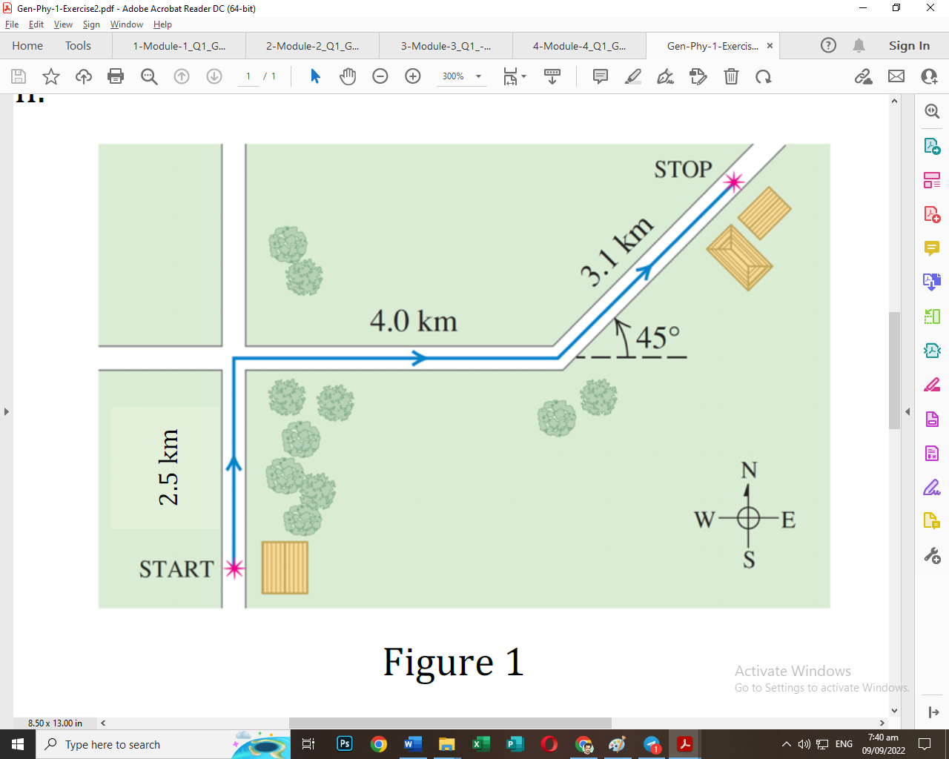dia

|  |  |  |  |  |
| --- | --- | --- | --- | --- |
| Vector | Magnitude  =  M | Direction  =  A | x-component  M(cos(A)) | y-Component  M(sin(A)) |
| A | 2.5 | 90 degrees | 0 | 2.5 |
| B | 4 | 0 degrees | 4 | 0 |
| C | 3.1 | 45 degrees | 2.19 | 2.19 |
| Summation of x and y components | | | 6.19 | 4.69 |

gr

C

B

A

am.

Mnew = New Magnitude

X = sum of x components

Y = sum of y components

Mnew =

Mnew =

Mnew =

Anew = New Direction

X = sum of x components

Y = sum of y components

Anew =

Anew =

A new

The resultant vector has a magnitude of 7.7 kilometers with a direction of 37 degrees north of east.

Scale Diagram is in the next page

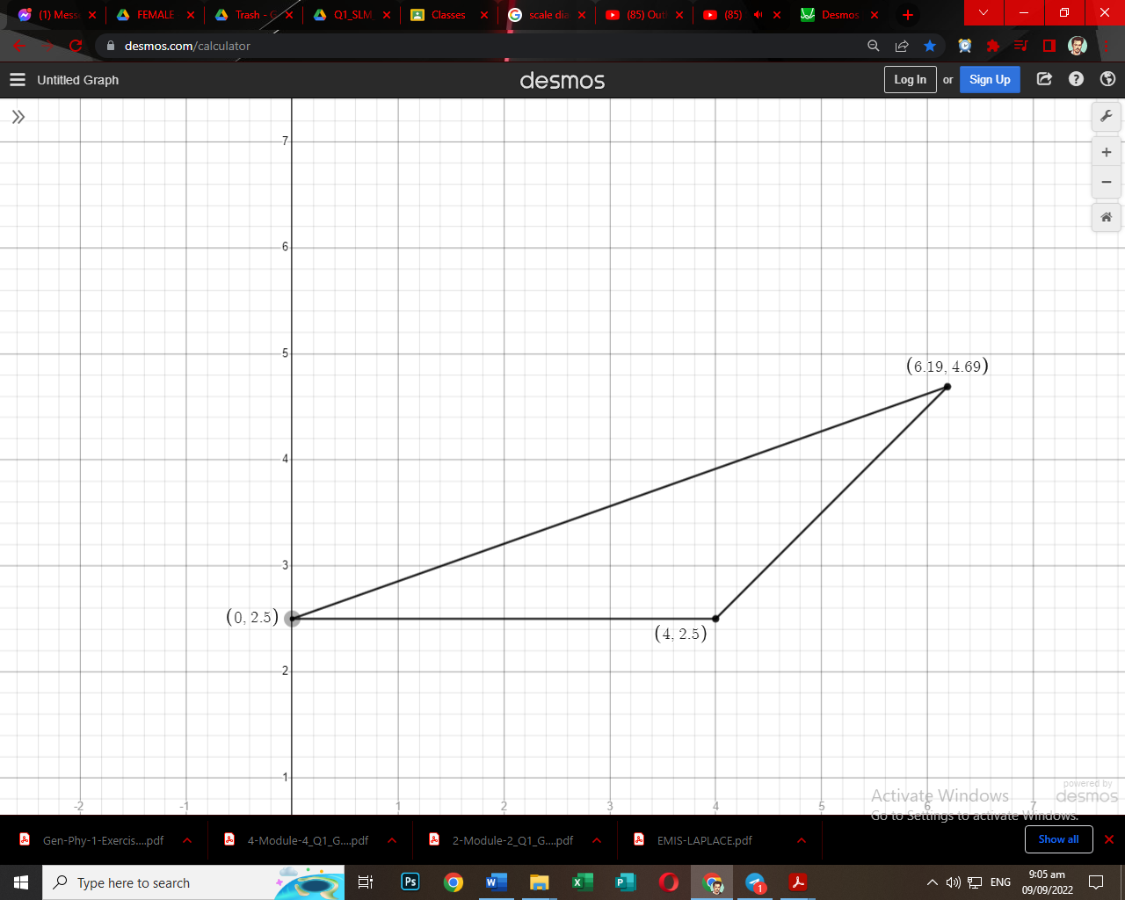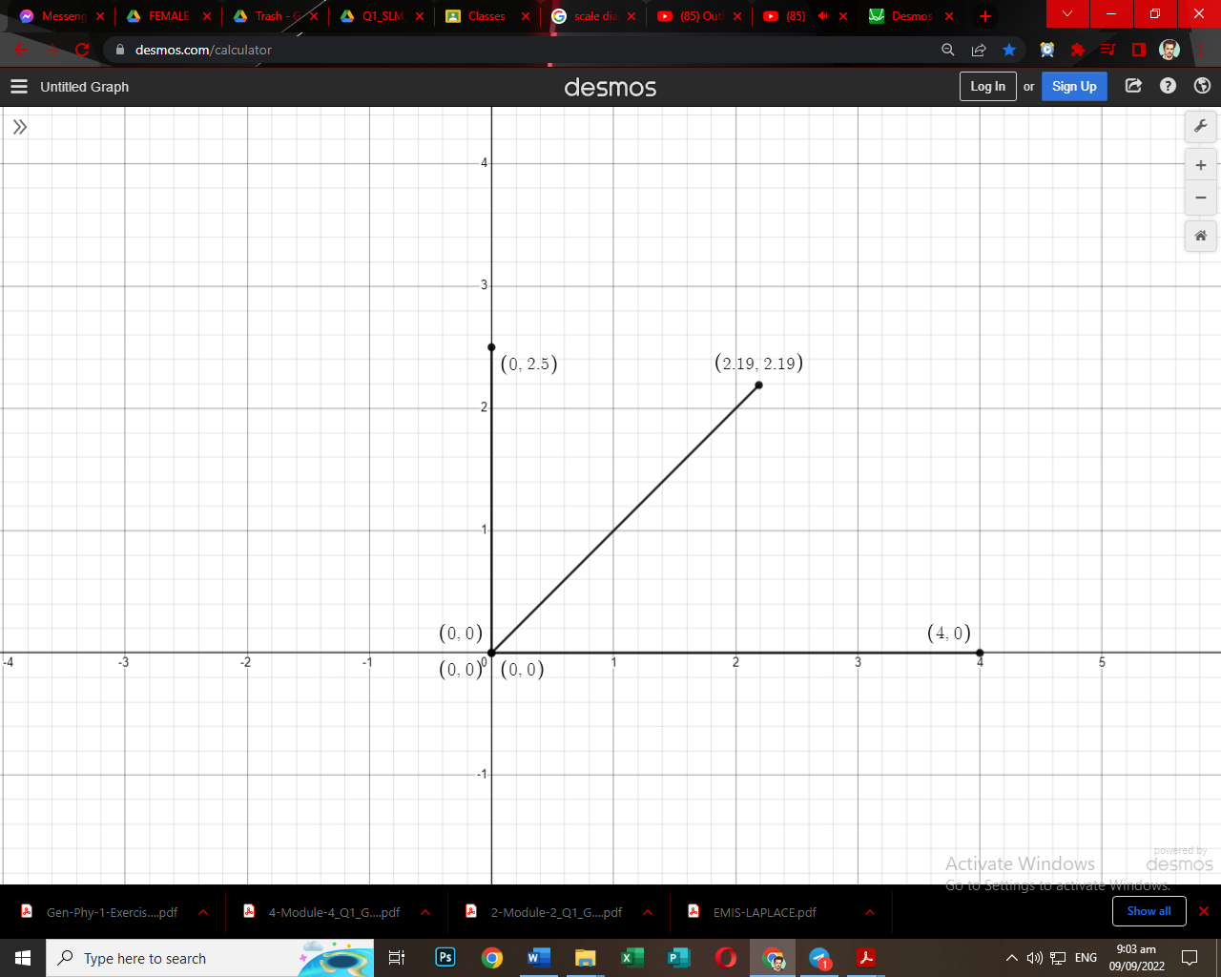

|  |  |  |  |  |
| --- | --- | --- | --- | --- |
| Vector | Magnitude  =  M | Direction  =  A | x-component  M(cos(A)) | y-Component  M(sin(A)) |
| A | 12 | 53 degrees | 7.22 | 9.58 |
| B | 15 | 320 degrees | 11.49 | -9.64 |
| C | 6 | 240 degrees | -3 | -5.2 |
| Summation of x and y components | | | 15.71 | -5.26 |

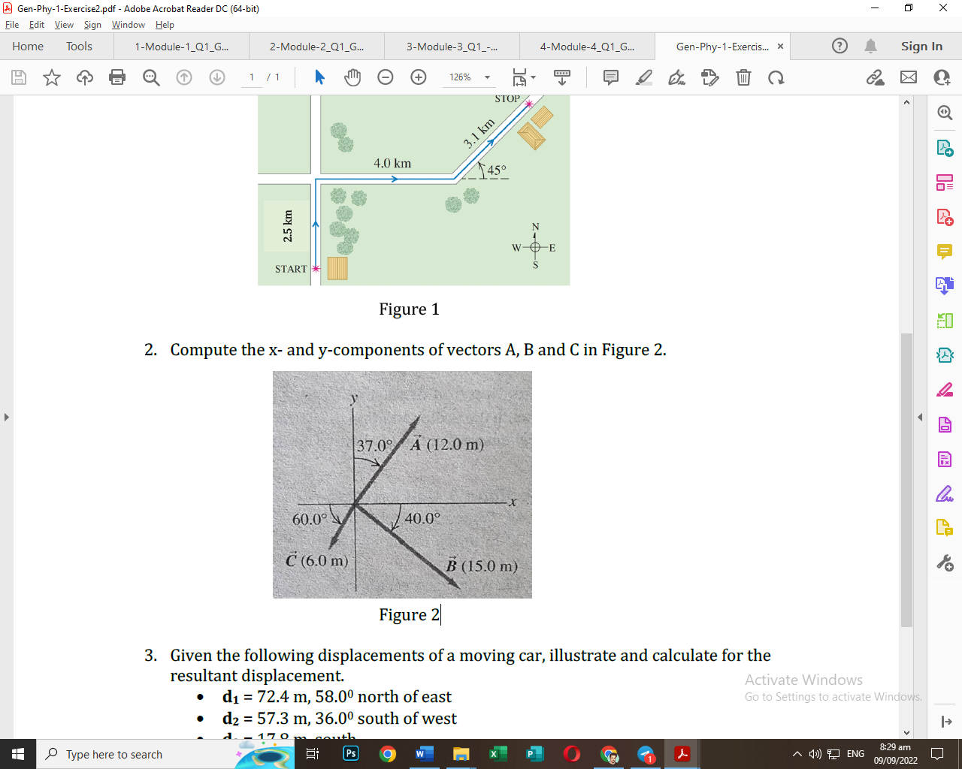

The resultant vector has a magnitude of 15.73 meters with a direction of 341 degrees along the x axis or -19 degrees south of east.

Mnew = New Magnitude

X = sum of x components

Y = sum of y components

Mnew =

Mnew =

Mnew =

Anew = New Direction

X = sum of x components

Y = sum of y components

Anew =

Anew =

Anew =

|  |  |  |  |  |
| --- | --- | --- | --- | --- |
| Vector | Magnitude  =  M | Direction  =  A | x-component  M(cos(A)) | y-Component  M(sin(A)) |
| D1 | 72.4 | 32 degrees | 61.4 | 38.37 |
| D2 | 57.3 | 213 degrees | -48.06 | -31.21 |
| D3 | 17.8 | 270 degrees | 0 | -17.8 |
| Summation of x and y components | | | 13.34 | -10.64 |

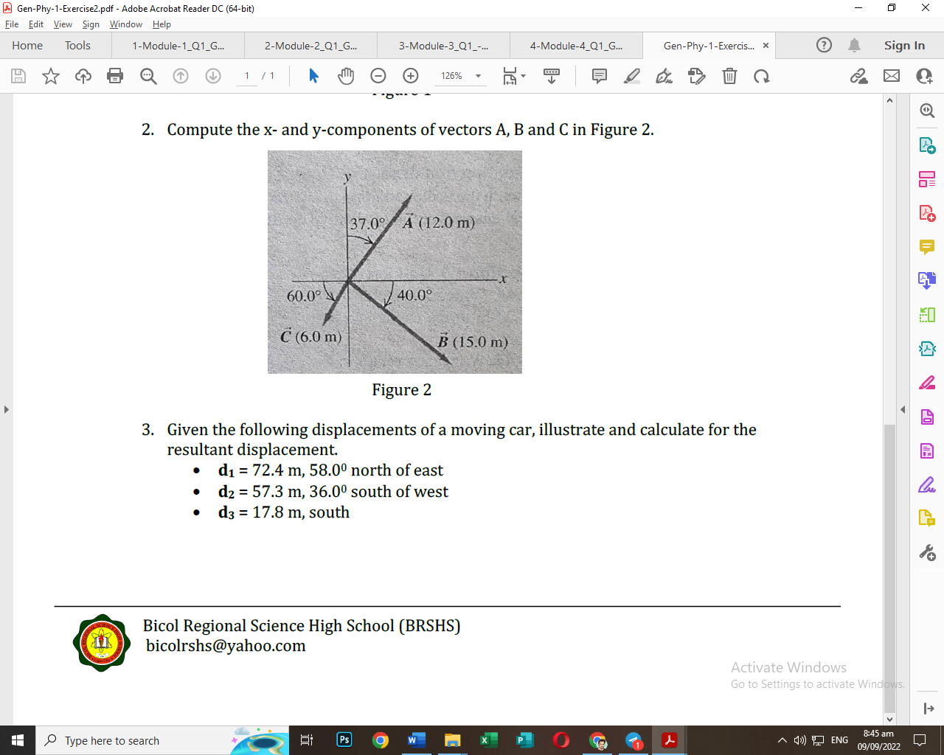

The resultant vector has a magnitude of 15.2 meters with a direction of 321 degrees along the x axis or -39 degrees south of east.

Mnew = New Magnitude

X = sum of x components

Y = sum of y components

Mnew =

Mnew =

Mnew =

Anew = New Direction

X = sum of x components

Y = sum of y components

Anew =

Anew =

Anew =